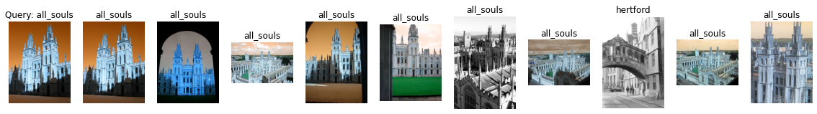

Label: all_souls

Average Precision for query 0: 0.5300521821923133

Precision@k for query 0: 0.9

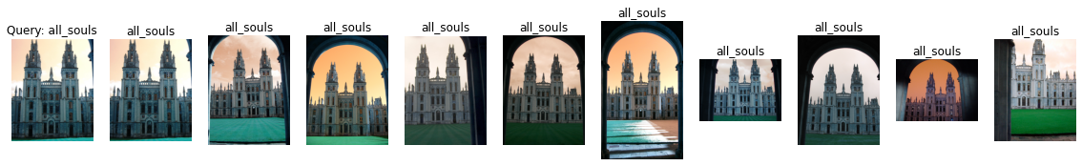

Label: all_souls

Average Precision for query 1: 0.6291103784911015

Precision@k for query 1: 1.0

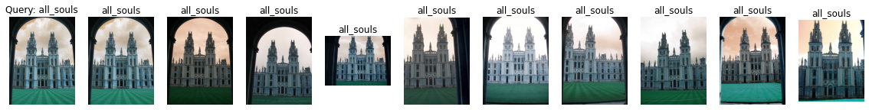

Label: all_souls

Average Precision for query 2: 0.6978010334180678

Precision@k for query 2: 1.0



Label: all_souls

Average Precision for query 3: 0.6814768296563084

Precision@k for query 3: 1.0

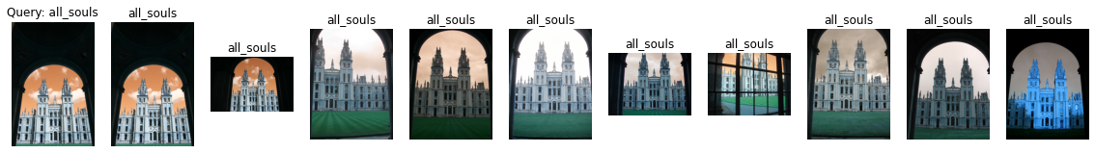

Label: all_souls

Average Precision for query 4: 0.6851942134402084

Precision@k for query 4: 1.0

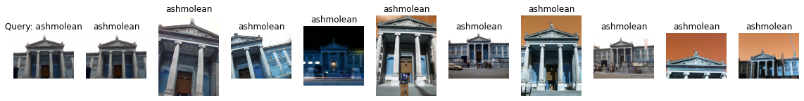

Label: ashmolean

Average Precision for query 5: 0.7169478000830563

Precision@k for query 5: 1.0

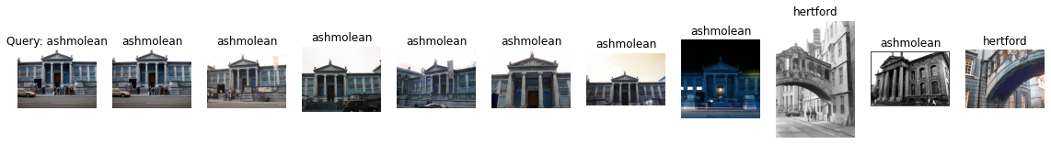

Label: ashmolean

Average Precision for query 6: 0.4118268852809414

Precision@k for query 6: 0.8

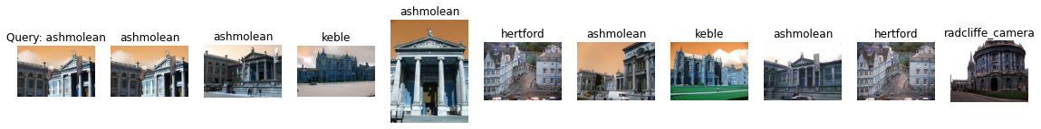

Label: ashmolean

Average Precision for query 7: 0.24851684507595084

Precision@k for query 7: 0.5

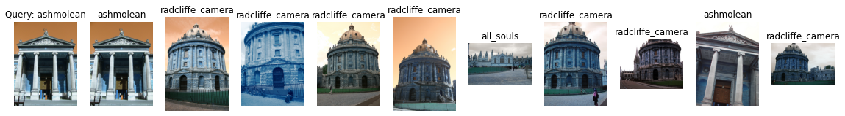

Label: ashmolean

Average Precision for query 8: 0.1513006810076099

Precision@k for query 8: 0.2

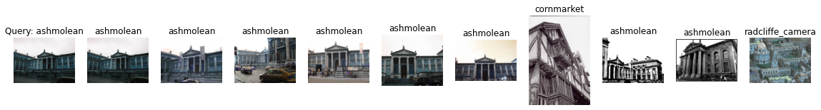

Label: ashmolean

Average Precision for query 9: 0.35795214859961183

Precision@k for query 9: 0.8

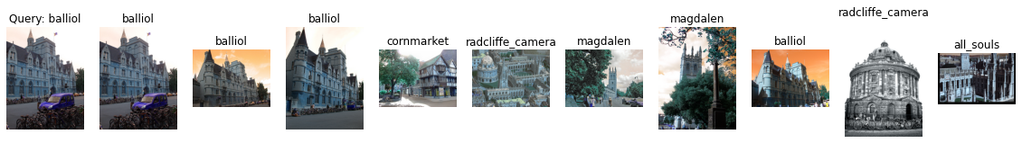

Label: balliol

Average Precision for query 10: 0.46392220956984764

Precision@k for query 10: 0.4

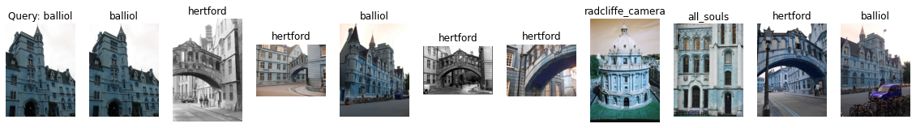

Label: balliol

Average Precision for query 11: 0.29229763589721386

Precision@k for query 11: 0.3

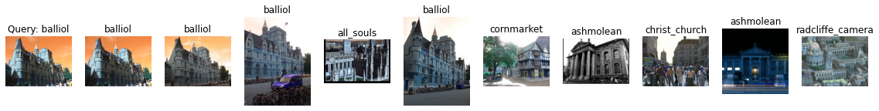

Label: balliol

Average Precision for query 12: 0.3812452067516882

Precision@k for query 12: 0.4

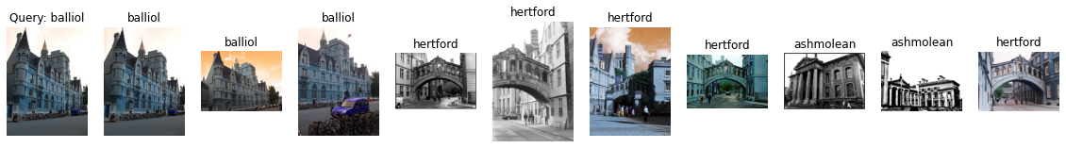

Label: balliol

Average Precision for query 13: 0.3415205146939619

Precision@k for query 13: 0.3

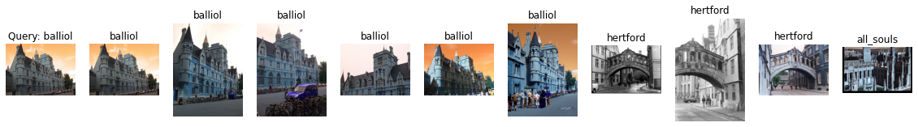

Label: balliol

Average Precision for query 14: 0.5956250397826578

Precision@k for query 14: 0.6

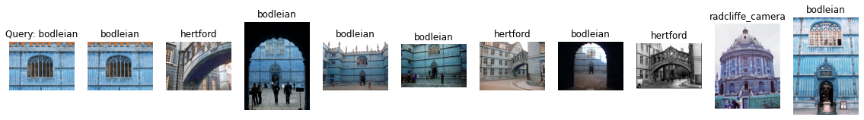

Label: bodleian

Average Precision for query 15: 0.33385055629710564

Precision@k for query 15: 0.6

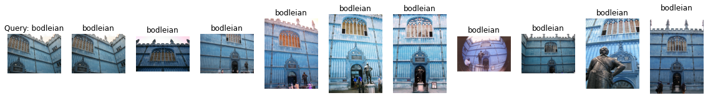

Label: bodleian

Average Precision for query 16: 0.6973878249054261

Precision@k for query 16: 1.0

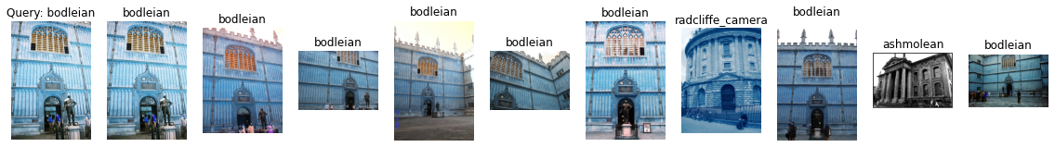

Label: bodleian

Average Precision for query 17: 0.4147969429489579

Precision@k for query 17: 0.8

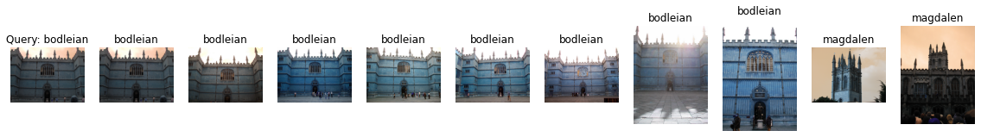

Label: bodleian

Average Precision for query 18: 0.5356566738879088

Precision@k for query 18: 0.8

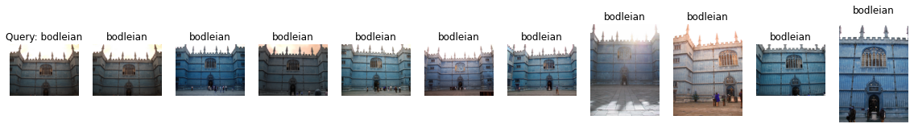

Label: bodleian

Average Precision for query 19: 0.6961109088702119

Precision@k for query 19: 1.0

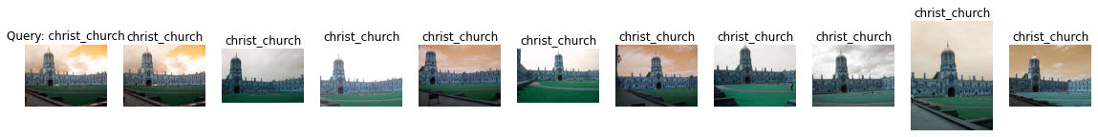

Label: christ_church

Average Precision for query 20: 0.7410546928150245

Precision@k for query 20: 1.0



Label: christ_church

Average Precision for query 21: 0.8116429891899972

Precision@k for query 21: 1.0



Label: christ_church

Average Precision for query 22: 0.7440236299010261

Precision@k for query 22: 1.0

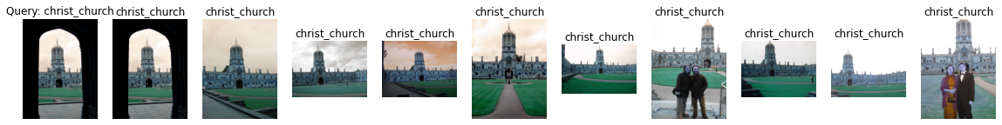

Label: christ_church

Average Precision for query 23: 0.751737785840211

Precision@k for query 23: 1.0

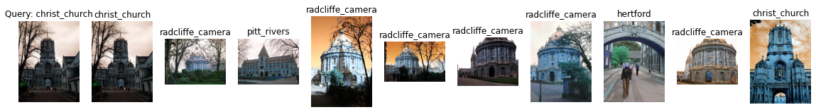

Label: christ_church

Average Precision for query 24: 0.11599893592602331

Precision@k for query 24: 0.2

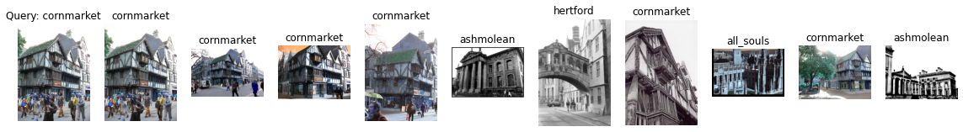

Label: cornmarket

Average Precision for query 25: 0.6212053189490914

Precision@k for query 25: 0.6

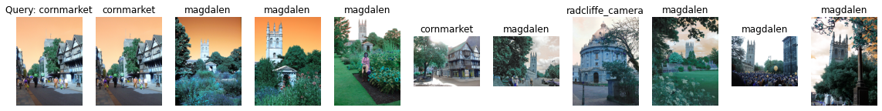

Label: cornmarket

Average Precision for query 26: 0.20570737073493506

Precision@k for query 26: 0.2

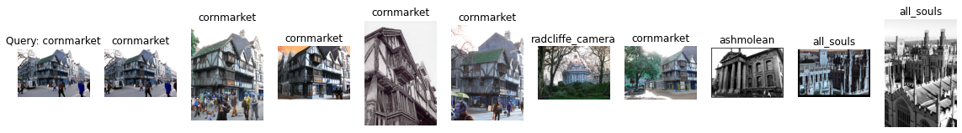

Label: cornmarket

Average Precision for query 27: 0.6677423050417813

Precision@k for query 27: 0.6

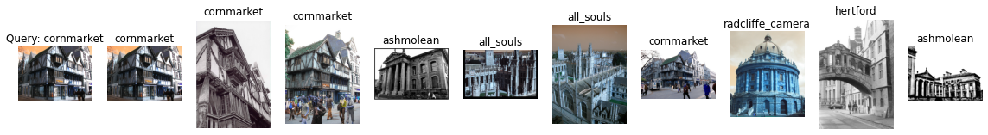

Label: cornmarket

Average Precision for query 28: 0.4749357700363784

Precision@k for query 28: 0.4

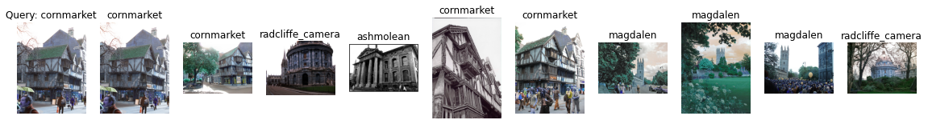

Label: cornmarket

Average Precision for query 29: 0.5018377575489645

Precision@k for query 29: 0.4

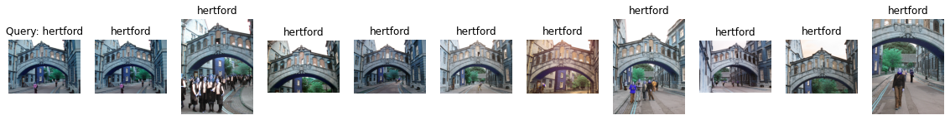

Label: hertford

Average Precision for query 30: 0.7965809194347401

Precision@k for query 30: 1.0

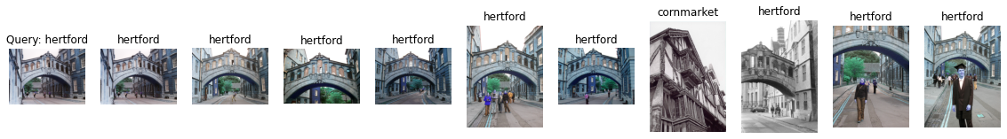

Label: hertford

Average Precision for query 31: 0.7130992718798222

Precision@k for query 31: 0.9

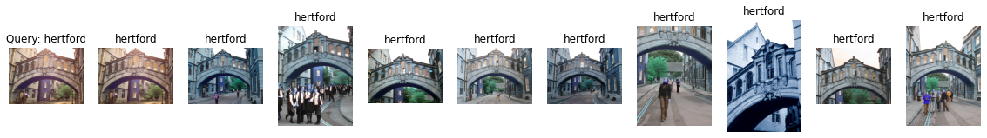

Label: hertford

Average Precision for query 32: 0.6901627697385735

Precision@k for query 32: 1.0

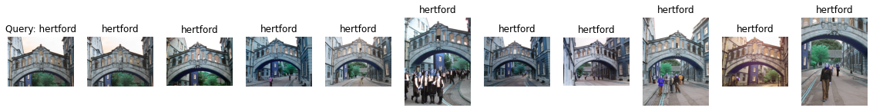

Label: hertford

Average Precision for query 33: 0.8050467574636924

Precision@k for query 33: 1.0

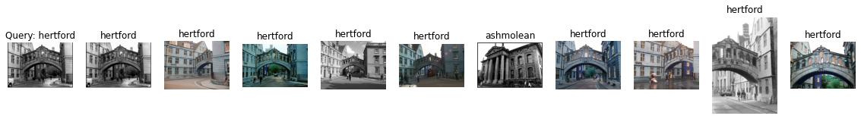

Label: hertford

Average Precision for query 34: 0.7025388810358356

Precision@k for query 34: 0.9

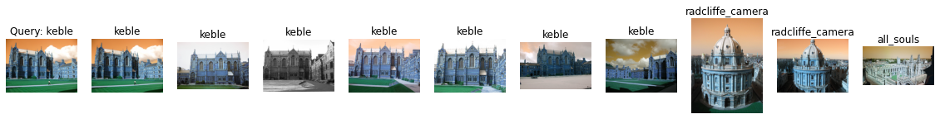

Label: keble

Average Precision for query 35: 1.0

Precision@k for query 35: 0.7

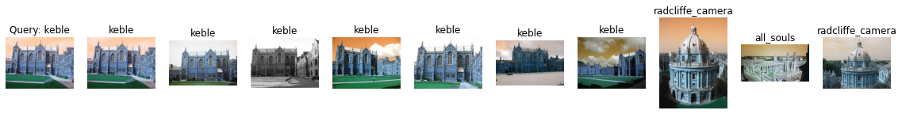

Label: keble

Average Precision for query 36: 1.0

Precision@k for query 36: 0.7

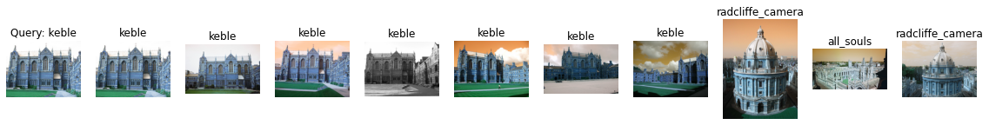

Label: keble

Average Precision for query 37: 1.0

Precision@k for query 37: 0.7

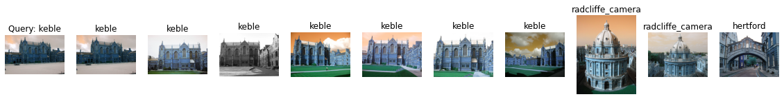

Label: keble

Average Precision for query 38: 1.0

Precision@k for query 38: 0.7

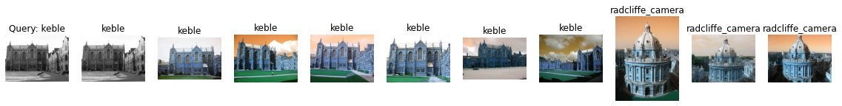

Label: keble

Average Precision for query 39: 1.0

Precision@k for query 39: 0.7

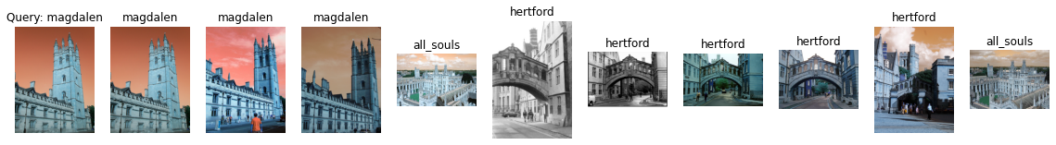

Label: magdalen

Average Precision for query 40: 0.1262527480013895

Precision@k for query 40: 0.3

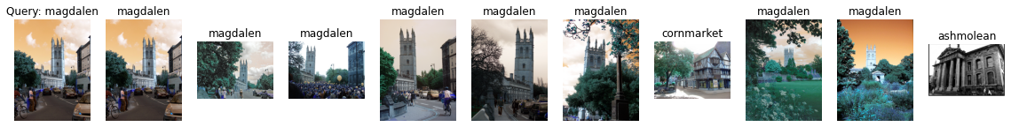

Label: magdalen

Average Precision for query 41: 0.4024582952971051

Precision@k for query 41: 0.8

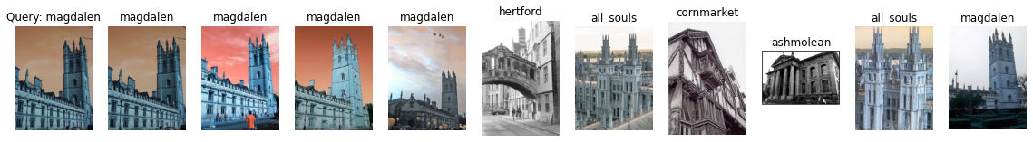

Label: magdalen

Average Precision for query 42: 0.17442275223659126

Precision@k for query 42: 0.5

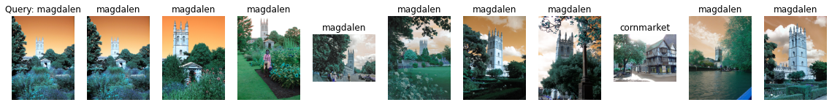

Label: magdalen

Average Precision for query 43: 0.5053624303170566

Precision@k for query 43: 0.9

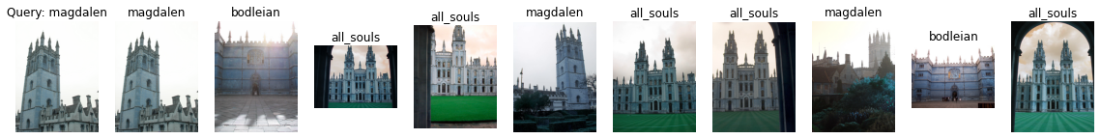

Label: magdalen

Average Precision for query 44: 0.20136086392717878

Precision@k for query 44: 0.3

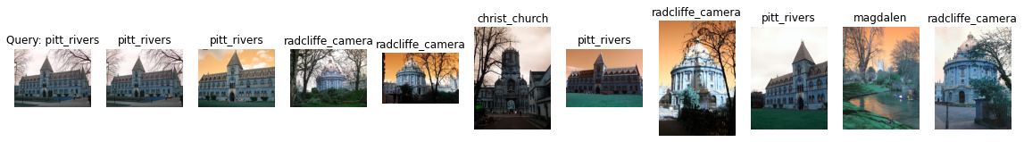

Label: pitt_rivers

Average Precision for query 45: 0.6282679738562091

Precision@k for query 45: 0.4

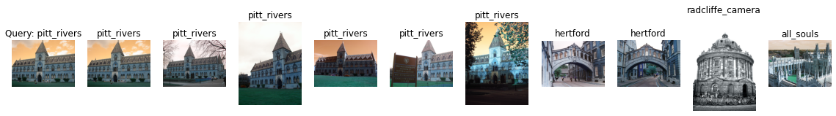

Label: pitt_rivers

Average Precision for query 46: 1.0

Precision@k for query 46: 0.6

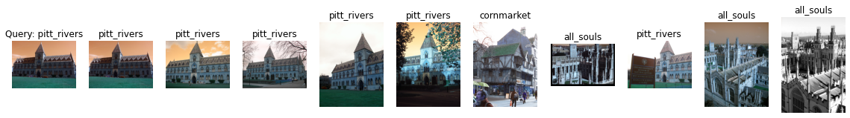

Label: pitt_rivers

Average Precision for query 47: 0.9583333333333334

Precision@k for query 47: 0.6

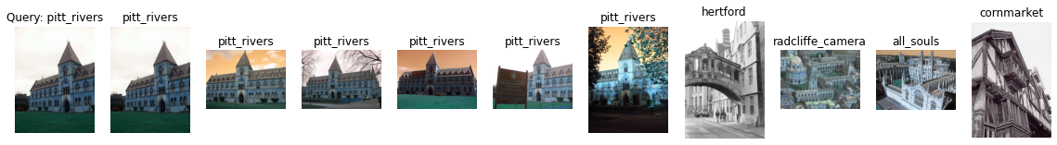

Label: pitt_rivers

Average Precision for query 48: 1.0

Precision@k for query 48: 0.6

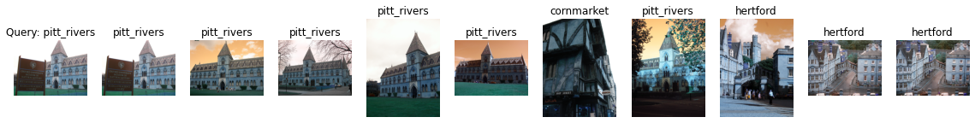

Label: pitt_rivers

Average Precision for query 49: 0.9761904761904762

Precision@k for query 49: 0.6

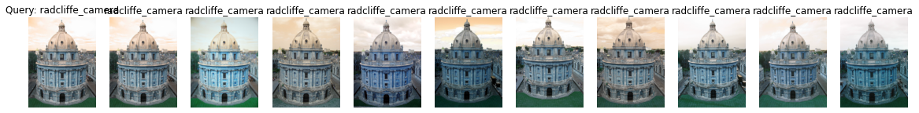

Label: radcliffe_camera

Average Precision for query 50: 0.7485668326112509

Precision@k for query 50: 1.0



Label: radcliffe_camera

Average Precision for query 51: 0.7855722610881272

Precision@k for query 51: 1.0

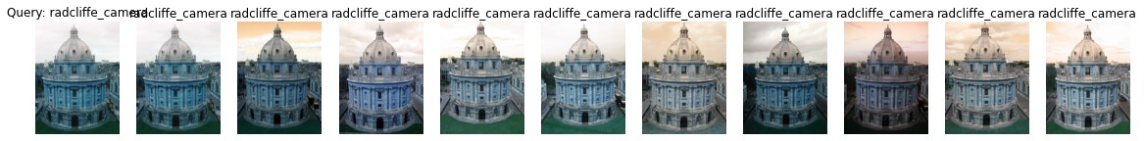

Label: radcliffe_camera

Average Precision for query 52: 0.7688247549776598

Precision@k for query 52: 1.0



Label: radcliffe_camera

Average Precision for query 53: 0.8121276128342003

Precision@k for query 53: 1.0

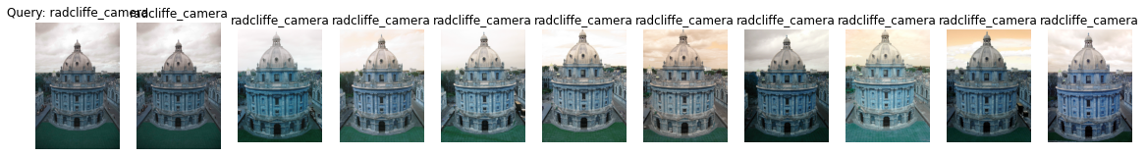

Label: radcliffe_camera

Average Precision for query 54: 0.7999782349903825

Precision@k for query 54: 1.0

mAP=0.6198841133826765